

UNIVERSITY OF WOLVERHAMPTON

DEVELOPMENT OF A PREDICTIVE MAINTENANCE SYSTEM FOR TURBOFAN JET ENGINES USING REAL-TIME ANOMALY DETECTION AND PERFORMANCE MONITORING

TITLE: DISSERTATION

STUDENT NAME: DANIEL CHIDIEBERE MADUIKE

STUDENT ID: 2401594

PROJECT SUPERVISOR: ANDREW GASCOYNE

# 

LIST OF TABLES 4

LIST OF FIGURES 5

ABSTRACT 7

1.0. INTRODUCTION 8

1.1. SIGNIFICANCE OF THE STUDY 11

1.2. AIM AND OBJECTIVES 12

1.3. RESEARCH QUESTIONS 12

2.0. LITERATURE REVIEW 13

2.1. INTRODUCTION TO PREDICTIVE MAINTENANCE 13

2.2. OVERVIEW OF TURBOFAN JET ENGINES 14

2.2.1. COMPONENTS OF A TURBOFAN JET ENGINE 14

2.2.2. WORKING PRINCIPLE OF THE TURBOFAN JET ENGINE 15

2.2.3. ADVANTAGES OF THE TURBOFAN JET ENGINE 16

2.2.4. CHALLENGES ENCOUNTERED WHEN UTILISING THE TURBOFAN JET ENGINE. 16

2.3. MACHINE LEARNING AND PREDICTIVE MAINTENANCE 16

2.4. DEEP LEARNING AND PREDICTIVE MAINTENANCE 18

2.5. TABLE SUMMARY OF LITERATURE REVIEW 21

3.0. METHODOLOGY 24

3.1. THE DATASET 25

3.2. DATA UNDERSTANDING 26

3.3. DATA PREPROCESSING 27

3.4. DATA VISUALISATION 29

3.5. DATA TRANSFORMATION 32

3.6. MACHINE LEARNING MODELS 33

3.6.1. LINEAR REGRESSION 33

3.6.2. RANDOM FOREST REGRESSOR 33

3.6.3. XGBOOST REGRESSOR 34

3.6.4. ARTIFICIAL NEURAL NETWORK (ANN) 35

3.6.5. CONVOLUTIONAL NEURAL NETWORK (CNN) 36

3.6.6. LONG SHORT TERM MEMORY (LSTM) 37

3.7. EVALUATION METRICS 38

4.0. EXPERIMENT AND RESULTS 40

4.1. MODEL TRAINING 40

4.2. MODEL EVALUATION 41

4.3. RESULT COMPARISON TO LITERATURE REVIEW 42

4.4. RESULT VISUALISATION FOR THE PROPOSED DATASETS SHOWING THE ACTUAL AND PREDICTED VALUES 44

4.4.1. RESULTS FOR DATASET 1 (FD 001) 44

4.4.2. RESULTS FOR DATASET 2 (FD 004) 50

4.5. KEY FINDINGS 56

5.0. CONCLUSION 57

5.1. LIMITATIONS AND FUTURE RECOMMENDATIONS 57

REFERENCE 59

# 

# LIST OF TABLES

|  |  |
| --- | --- |
| table 2.1: literature review | 21 |
| Table 3.1: evaluation metrics | 40 |
| Table 4.1: results from the first dataset FD001 | 43 |
| Table 4.2: results from the second dataset FD004 | 44 |

# LIST OF FIGURES

|  |  |
| --- | --- |
| Figure 2.1: A turbofan jet engine (Wikipedia contributors, 2025) | 14 |
| Figure 3.1: parts of a turbofan jet engine (Radtke, 2023) | 25 |
| Figure 3.2: dataset insight | 27 |
| Figure 3.3: train RUL preprocessing | 28 |
| Figure 3.4: checking for missing values | 29 |
| Figure 3.5: feature extraction | 30 |
| Figure 3.6: correlation matrix for FD001 | 31 |
| Figure 3.7: correlation matrix for FD004 | 32 |
| Figure 3.8: the random forest regressor (Kharkar, 2023) | 35 |
| Figure 3.9: the artificial neural network (GeeksforGeeks, 2024) | 37 |
| Figure 3.10: Convolutional neural network (Dandekar, 2023) | 38 |
| Figure 3.11: long short-term memory (LSTM) (Hesaraki, 2023) | 39 |
| Figure 4.1: Showing the true and predicted values of Linear regression | 45 |
| Figure 4.2: Showing the true and predicted values of random forest | 46 |
| Figure 4.3: Showing the true and predicted values of XGboost | 47 |
| Figure 4.4: Showing the true and predicted values of Artificial neural network | 48 |
| Figure 4.5: Showing the true and predicted values of convolutional neural network | 49 |
| Figure 4.6: Showing the true and predicted values of LSTM | 50 |
| Figure 4.7: Showing the true and predicted values of Logistic regression | 51 |
| Figure 4.8: Showing the true and predicted values of random forest | 52 |
| Figure 4.9: Showing the true and predicted values of XGboost | 53 |
| Figure 4.10: Showing the true and predicted values of artificial neural network | 54 |
| Figure 4.11: Showing the true and predicted values of convolutional neural network | 55 |
| Figure 4.12: Showing the true and predicted values of LSTM | 56 |

# 

# ABSTRACT

The prediction of the remaining useful life (RUL) of a turbofan jet engine is a critical task in the field of telemetry and predictive maintenance as it enables timely interventions which prevent engine failures and optimises efficiency in aircraft engine operations. In recent years, the adoption of machine learning and deep learning has proven to be powerful tools and techniques for accurately estimating the remaining useful life by utilising sensor data of the engines and its operational parameters. This research explores the application of machine learning (ML) and deep learning (DL) models on the CMAPSS dataset obtained from Kaggle with model implementations such as Linear regression, Random Forest regressor, XGBoost regressor, Artificial Neural Networks (ANN), Convolutional Neural Networks (CNN), Long short term memory (LSTM) and a hybrid model of ANN and CNN. After the training and evaluation of the models on the prediction of the remaining useful life of the turbofan jet engine, the XGBoost and the Random Forest regressor demonstrated superior performance on the first and second datasets FD001 and FD004, achieving a RMSE of 0.38 and 0.31 respectively. Challenges encountered during the experiment include the presence of noise in the data which is typical for any telemetry sensor data. This limitation was also borne from the review of previous literature, and it was solved using the exponential moving average smoothing technique. This research highlights the potential of machine learning and deep learning models in achieving a high predictive power in the field of telemetry.

# 

# 1.0. INTRODUCTION

Predictive maintenance essentially handles the engine's reliability issue by guaranteeing that the aero-engine can function normally under specific conditions (Ramírez, 2022). This is a crucial requirement for aircraft safety since malfunctions in safety-critical systems, such as aircraft engines, can result in serious accidents that could claim lives and significant financial losses (Sadaf *et al.*, 2023). Because of this, it is essential to predict engine failure to keep safety-critical systems operating, which raises the bar for engine performance status monitoring (Madni, Madni and Lucero, 2019). To reduce the number of unscheduled maintenance events, the aerospace maintenance industry is shifting towards cutting-edge technologies, such as predictive maintenance systems based on health monitoring, that can identify degradation early and proactively schedule maintenance procedures (Wang *et al.*, 2020). Therefore, predicting when an engine will fail is important for preserving the operation of safety-critical systems. Condition monitoring systems have been developed because of advanced sensor technology. Combining appropriate data mining techniques should be the cutting edge of multi-modal data analysis for industrial applications.

Nowadays, data-driven techniques for gas turbine engine health monitoring have been published by different authors. The system can be either a classification, clustering, regression or dimensionality reduction system. In this kind of analysis, regression-based methods are widely employed. These regression methods use regression models to fit multi-dimensional multivariate data, and then detect abnormalities based on the predictions of the remaining useful life (RUL) using regression models and the differences in data observations (Sai *et al.*, 2023). The neighborhood-based approach is another subject associated with anomaly detection in turbojet engines (De Castro Cros, 2023). This approach determines the distance or relative density between a sample point and its neighbourhood as an anomaly score after defining a neighbourhood using a distance or similarity measuring technique (Samara *et al.*, 2022). In this method, the k-nearest neighborhood (KNN) and local outlier factor (LOF) are among the best-known algorithms used to conduct quantitative analysis of the flight data outlier detection (Yang *et al.*, 2022). However, there are several issues associated with the anomaly detection algorithm development process for any engine data. First, there is an issue of dataset availability as there are not many publicly available data sets. This genuine engine data is hard to get due to confidentiality concerns and the quantity of defects contained is extremely unusual which may also lead to unbalanced data. Developing algorithms for detection requires data sets, particularly fault data for verification and the lack of robust data is a major limiting factor (Baduge *et al.*, 2022). Secondly, only a handful of the numerous machine learning algorithms—that is, those without an integrated detection algorithm library—are appropriate for engine detection (Budhwar *et al.*, 2023). Baseline construction, anomaly identification, and trend prediction are all part of the full engine monitoring process, which calls for the collaboration of several algorithms and most of these also require specific domain knowledge. Availability of data but limited knowledge of the field may be a problem for data scientists and analysts who can model the data but lack the necessary preprocessing skills for the field. Finally, there are far too many uses of traditional machine learning algorithms and few attempts to utilise novel artificial intelligence algorithms for engine health monitoring and fault detection.

The study of anomaly detection is a dynamic field that includes many methods created in several domains, such as machine learning, statistics, process control, and signal processing. The objective is to be able to recognise data that does not match or deviate from what is regarded as normal, expected, or likely based on the shape and amplitude of a signal in a time series, or the data probability distribution (Nemani *et al.*, 2023). Anomaly is also frequently referred to as an outlier, and the terms are also used in place of the other (Lim *et al.*, 2020). Additionally, even though the underlying detection techniques are usually the same, some researchers prefer the term novelty detection over anomaly detection when the objective is to find data that differs in some way from historically observed data (Mundt *et al.*, 2023). Novelty data differs from anomalies in that novelty data are typically regarded as normal data once they are discovered. One of the primary obstacles in anomaly identification is the failure to distinguish between normal and anomalous instances because, in certain application domains, the line separating the two is frequently obscure and changes over time (Spahić *et al.*, 2023). In addition, because anomalies are frequently infrequent occurrences, labelled datasets for model validation and training are either unavailable or significantly skewed towards typical cases (Herteux *et al.*, 2024). This leads to a case of data imbalance which may pose a significant challenge in model training and evaluation but with statistical methods of class balancing, there are several methods currently employed in the field where there is a significant data imbalance (Li *et al.*, 2021). Because of this imbalance or skewed data distribution, some researchers often tend toward unsupervised methods of anomaly detection. In a semi-supervised approach for anomaly detection, it is perceived that class labels exist only for the normal class in the training set (Borisov *et al.*, 2022). If there are any unlabelled features, they are assumed to have the same label as the labelled features that are nearby in the data. As the data should contain a majority of normal data, the model is trained to learn the normal behaviour of a system and then used during the test phase to identify misnomers (Andresini, Appice and Malerba, 2021). In contrast, techniques for unsupervised learning only assume that anomalies are either located in low-density areas or far from the majority of data instances, or that a very small percentage of the total data is anomalous data (Tao *et al.*, 2022).

The aviation sector continues to face several challenges despite its quick growth, including factors like fuel costs, aircraft maintenance, increased air traffic, competition amongst rivals, recession, air pollution, security, and operational difficulties. Roughly 40% of all aviation system operating expenses go towards aircraft maintenance (Rojas-Michaga *et al.*, 2023). The implementation of appropriate health monitoring for a particular flying service will improve operational efficiency and reduce the need for emergency aircraft maintenance (Yu *et al.*, 2022). Due to the high expense of maintenance in the industry, aircraft engines must function within certain physical parameters (Park and Kim, 2022). Even though contemporary engines have more sensors and control variables, they might still break down due to normal wear and tear (Vishnuram *et al.*, 2023). Early detection can stop minor problems from becoming more complex and possibly mitigate accidents. The incidence of accidents and technical issues is directly proportional to the aircraft's manufacturing speed. For estimating and optimising flight characteristics in real time, the Engine Test Bed simulates real flights. Different Line Replacement Units (LRUs) or pieces of equipment make up flight parameter optimisation systems (Ulansky and Raza, 2023). Extensive data, including meteorological conditions, pilot preferences, and system health factors, are continuously logged in commercial aircraft. These robust datasets are subjected to data mining techniques to find important trends. Enhancing the general health of the aircraft and lowering airline operating costs are the main objectives of analysing such vast databases. Aircraft alarm systems can quickly identify potentially fatal situations. There is a growing interest in better-estimating techniques for aircraft health metrics and their variations as determined by sensor readings. Better engine safety, lower life cycle costs, and lower overhaul prices can result from efficient engine parameter optimisation. An ETB facility is used in conventional aircraft engine optimisation to evaluate and enhance the engine's performance while in flight but even though aircraft engines operate differently in the air, ETB is a time-consuming method that can only assess and optimise them on the ground. Maintenance procedures in this research are based on the Remaining useful life (RUL) which refers to the estimated amount of time or operational cycles in which a system, component or engine is expected to function properly before it requires maintenance or replacement (Nemani *et al.*, 2023). The health of machines is typically detected and predicted using statistical, artificial intelligence, or model-based approaches. The usage of artificial intelligence (AI) in predictive maintenance (PdM) applications is growing because model-based approaches necessitate mechanical and theoretical knowledge of the equipment, whereas statistical approaches rely on mathematical backgrounds (Cummins *et al.*, 2024). Because artificial intelligence (AI) can learn patterns from data and perform predictive analysis, it performs better than statistical methods in anticipating equipment failure (Baduge *et al.*, 2022). Machine learning and deep learning-based prediction algorithms can handle high dimensional and multivariate data in dynamic situations and identify inert relationships within data.

This research aims to develop some machine learning and deep learning algorithms that combine regression and time series analysis. The machine learning and deep learning models proposed in this paper are linear regression, random forest, XGBoost, artificial neural network (ANN), convolutional neural network (CNN), long short-term memory (LSTM) and a hybrid model of ANN and CNN. These models were chosen because of their strength in time series analysis while some models such as random forest and convolutional neural networks (CNN) would be used as baseline models for comparison between the various models.

## 1.1. SIGNIFICANCE OF THE STUDY

The significance of this study of a Predictive Maintenance System for Turbofan Jet Engines using anomaly detection lies in its potential to bring about a change in the maintenance system and mode of operation of the jet engines by providing an efficient system of management (Elahi *et al.*, 2023). Predictive maintenance (PdM) anomaly detection can enhance operational efficiency and safety in the aircraft industry (Menon and Tuladhar, 2024). Because traditional maintenance methods are costly due to unplanned downtime or inefficiencies, it is necessary to employ machine learning algorithms using sensor data which reduces operational costs (Zvarivadza *et al.*, 2024). Also, the model of a collection of the data in a continuous cycle enables continuous assessment of the engine health (Dhanaraju *et al.*, 2022). Also, this study contributes to the advancement of aviation systems by the optimisation of maintenance schedules and reduction of unexpected engine failures which prolongs the lifespan of engine components. Finally, the methodologies developed in this research can serve as a defined system for predictive maintenance in other industries.

## 1.2. AIM AND OBJECTIVES

This study aims to develop a predictive maintenance system for turbofan jet-propelled engines by utilising anomaly detection and performance monitoring with the following objectives:

* Design and implement machine learning and deep learning algorithms to predict the remaining useful life (RUL) for the jet engines using the CMAPSS dataset.
* Determine the most effective model for predictive analysis and anomaly detection.
* Utilise two datasets from the CMAPSS real-time dataset folder and compare the dataset performance on the same machine learning model.
* Evaluate the performance of the machine learning models using statistical methods such as R2, root mean square error and mean absolute error for regression analysis.
* Introduce smoothing which was a major limitation from the previous literature to reduce the RMSE of the machine learning and deep learning models.

## 1.3. RESEARCH QUESTIONS

* How accurately can real-time telemetry data be used effectively to detect anomalies in turbofan jet engine performance?
* How accurately can machine learning predictive models estimate the remaining useful life (RUL) of turbofan engine components?
* How can data distribution affect the performance of models used for predictive maintenance and anomaly detection?
* How well can statistical evaluation metrics portray the performance of models in predicting the remaining useful life (RUL) of engines?
* What is the effect of applying smoothing on the dataset?

# 

# 2.0. LITERATURE REVIEW

The development of predictive maintenance systems for turbofan jet engines represents a critical advancement in the aviation industry as well as any industry that deals with motor propulsion systems, aiming to enhance operational efficiency, reduce maintenance costs, and ensure flight safety and safety in the environment in which the engine would operate (Pons-Prats, Živojinović and Kuljanin, 2022). This literature review provides a comprehensive examination of the foundational concepts, methodologies, technologies that underpin this field and finally previously published papers in the field in general. The review is structured into three key sections: an introduction to predictive maintenance, which explores its evolution, principles, and significance in modern engineering, an overview of turbofan jet engines, focusing on their design, operational characteristics, and common failure modes and a detailed analysis of machine learning and deep learning systems applied to predictive maintenance, highlighting their role in real-time anomaly detection and performance monitoring. By utilising existing research, this section establishes the practical framework necessary for the development of an advanced predictive maintenance system tailored to turbofan jet engines.

## 2.1. INTRODUCTION TO PREDICTIVE MAINTENANCE

Predictive maintenance (PdM) has appeared as a transformative approach in modern engineering, revolutionising the way industries monitor and optimise the performance of important equipment (Apeiranthitis *et al.*, 2024). Unlike primitive maintenance systems which address failures after they have occurred, predictive maintenance makes use of data, data analysis, and machine learning to predict failures in machines way before they happen (Manchadi, Ben-Bouazza and Jioudi, 2023). By constantly monitoring the condition of machines and figuring out early signs of malfunctions, it enables checkups to be done on time which minimises failure, reduces maintenance costs, and prolongs the remaining useful life of the machine. In important areas like aviation or motor transport, where equipment reliability and efficiency are important, predictive maintenance offers a solution to ensure operational safety (Amir *et al.*, 2023). For complex systems such as turbofan jet engines, which operate under extreme conditions and are constantly prone to wear and tear, the ability to predict and prevent failures is extremely important. The integration of state-of-the-art technologies such as sensor networks, the Internet of Things (IoT), and artificial intelligence (AI), has improved the capabilities of predictive maintenance systems further, making them highly effective and important in the era of smart manufacturing and Industry 4.0.

## 2.2. OVERVIEW OF TURBOFAN JET ENGINES

The turbofan jet engines are the foundation of modern aviation which powers the majority of aircraft due to their superior efficiency and performance. It is a type of gas turbine engine and is designed to generate thrust by accelerating air through a series of precisely engineered components. What distinguishes turbofan engines apart from other jet engines is the addition of a bypass system, which tremendously enhances fuel efficiency and at the same time, reduces noise.

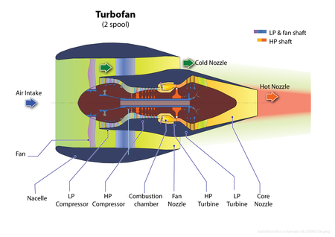

Figure*2*.1*: A turbofan jet engine (Wikipedia contributors, 2025)*

## 2.2.1. COMPONENTS OF A TURBOFAN JET ENGINE

* Fan: This is the most notable feature at the front of the engine. It comprises a large set of rotating blades that draw in a significant volume of air. This air is split into two streams which are the bypass air, which flows around the core of the engine, and the core air, which finds its way into the engine’s core for combustion.
* Compressor: This is a multi-stage component responsible for increasing the pressure of the core air before it enters the combustion chamber. It is divided into two main sections which are the low-pressure compressor (LPC) and the high-pressure compressor (HPC).
* Combustion chamber: Here, the highly compressed air is then mixed with fuel and ignited, producing a high-temperature, high-pressure gas. This process releases immense energy, which is used to drive the turbine stages. This component operates under extreme thermal conditions hence it needs advanced materials and cooling mechanisms to prolong its lifespan.
* Turbine: This component extracts energy from the high-pressure gas generated in the combustion chamber. It is also divided into two main stages just like the compressor. The divisions are the high-pressure turbine (HPT) and the low-pressure turbine (LPT). It drives both the compressor and the fan through some interconnected shafts, making sure that there is continuous operation of the engine.
* Bypass duct: This surrounds the engine core, allowing a significant amount of the air drawn in by the fan to bypass the core in its entirety. This air which is bypassed generates additional thrust with little consumption of fuel, making these types of engines more efficient than traditional turbojets.
* Nozzle: This is where the exhaust section of the engine is located. Here, the high-velocity gases from the core and bypass air are ejected to generate thrust. The design of the nozzle is specifically made for engine performance optimisation, fuel efficiency, and noise reduction.

## 2.2.2. WORKING PRINCIPLE OF THE TURBOFAN JET ENGINE

The working principle of this engine can be summarised into four basic steps:

* Intake: This is when the fan draws in air, splitting it into bypass air and core air.
* Compression: In this stage, the core air is compressed, significantly increasing its pressure and temperature.
* Combustion: The compressed air from above is then mixed with fuel and ignited in the combustor, producing high-energy gas.
* Expansion and exhaust: Here, the high-pressure gas expands through the turbine stages, driving the fan and compressor, which is finally ejected through the nozzle to generate thrust.

## 2.2.3. ADVANTAGES OF THE TURBOFAN JET ENGINE

* It is highly efficient and is better than the traditional engines because bypass air contributes to thrust without requiring additional fuel.
* This bypass air aids in dampening of noise making it more efficient for environmental protection.
* This type of engine is ideal for commercial aircraft since it provides good performance while maintaining low density.

## 2.2.4. CHALLENGES ENCOUNTERED WHEN UTILISING THE TURBOFAN JET ENGINE.

* Fan blade damage
* Compressor stall
* Combustor and turbine degradation
* Bearing failures
* Corrosion of engine components

## 2.3. MACHINE LEARNING AND PREDICTIVE MAINTENANCE

Machine learning is a branch of artificial intelligence (AI) that focuses on developing statistical models that enable computers to learn from and make predictions based on input data (Nguyen *et al.*, 2021). Unlike traditional programming, where prior defined instructions are provided, machine learning improves their performance over time by learning patterns and relationships within the data they interact with. Predictive maintenance is one of the major aspects in which machine learning can be applied in industrial settings. It involves using data analysis techniques to determine when a piece of equipment is likely to break down, allowing maintenance or preventive measures to be put in place just in time to prevent unexpected engine breakdown (Friederich and Lazarova-Molnar, 2023). Predictive maintenance alongside machine learning helps to optimise maintenance schedules and reduce costs. In predictive maintenance, machine learning models analyse data from sensors or logs to identify patterns which signify possible equipment failures (Ucar, Karakose and Kırımça, 2024). Machine learning models can predict the remaining useful life (RUL) of components and detect anomalies. This section contains a review of previous literature on predictive maintenance using machine learning techniques.

Taşcı et al. (2023), proposed a system to address the issue of predicting potential failure in equipment on assembly lines before they occur using machine learning models. In this research, the authors developed some machine learning models such as the random forest, extreme gradient boosting, multilayer perceptron and support vector machine. The dataset utilised in this research was collected from a real-world assembly line that manufactures consumer hygiene products where each production line was embedded with IoT sensors that measure and collect various sensor readings. With this information, it is safe to state that the authors utilised two complementary datasets, sensor data and unplanned stop data. The first dataset consists of 101 features and 8.6 million instances of which 50 were sensor readings while 50 others were timestamps. The second dataset was the stop dataset which consists of 34 columns and 6787 rows and was generated from the production line. The dataset had 27 unique failure types that caused a production stop. The preprocessing steps taken by the authors here were the regular ones for any numerical machine learning project such as min-max normalisation as the sensor data values varied widely, the missing values were filled using the median of the feature distribution and finally, the timestamp was recalibrated to turkey, which was the local time for the authors. The data was split into 70:30 for training and testing purposes respectively and a hyperparameter tuning of cross-validation was applied. After the training process on the first data test, the random forest achieved a high r2 score of 0.9 while the MLP achieved a r2 score of 0.45. On the second dataset, the random forest achieved a r2 score of 0.9 also and the MLP achieved a lower score of 0.695. In this research, the random forest was the best-performing model and we can see the trade-off between model accuracy and dataset distribution. A major challenge the authors faced in this research was computational efficiency, as the dataset was quite big, so deep learning architecture was omitted from the research, so they recommended more complex deep learning algorithms for future research.

Kanadaway et al. (2017), proposed a predictive approach for predictive maintenance of industrial machines using IoT sensor data. In this research, the authors utilised supervised learning algorithms such as naive Bayes, Support Vector Machine (SVM), CART and deep neural network. The dataset generated for this research was obtained from a slitting machine with 14 arms which produces variable-sized packaging rolls from a huge wound roll. After training this model the deep neural network achieved the highest accuracy of 98.69 prediction accuracy. The future scope recommended by the authors was the determination of the remaining useful life of the machine using these systems of algorithms and preferably using a stacked system of algorithms to increase confidence of the prediction.

## 2.4. DEEP LEARNING AND PREDICTIVE MAINTENANCE

Deep learning is a branch of artificial intelligence (AI) and is also a very powerful approach which utilises the power of neural networks to model complex patterns and relationships in any given data (Kautz, 2022). Unlike classical machine learning models, deep learning is successful at automatically extracting features from data which makes it the best for tasks involving large datasets, such as sensor data (Ahmed *et al.*, 2023). Its ability to handle complex data and learn patterns has made it an important technique in the field of predictive maintenance. Here, deep learning models are applied in the analysis of data collected from industrial equipment. These deep-learning models can identify the most subtle anomalies which may indicate early signs of equipment degradation (Elahi *et al.*, 2023). For example, the Long short-term memory (LSTM) can process sequential data in time-series sensor data to detect anomalies in the life cycle of the machine. This section provides information on previous literature involving deep learning and predictive maintenance.

Lee et al. (2023) just proposed a predictive approach for determining the remaining useful life of aircraft maintenance using deep reinforcement learning. In this research, the authors utilised the convolutional neural network (CNN) to estimate the distribution of the remaining useful life using Monte Carlo dropout, they further proposed another deep reinforcement learning model to handle maintenance action problems which arose as a result of the estimates of the remaining useful life. In this research, the authors utilised the C-MAPSS dataset for turbofan jet engines which consists of four different train and test data types corresponding to different fault modes. These dataset labels are FD001, 2, 3, and 4 with 1, 1, 2, and 2 fault modes respectively. The models utilised in this research were multichannel CNN with Monte Carlo dropout, single channel CNN with Monte Carlo dropout, DCNN, MS-DCNN, CNN with pooling and lastly, CNN with pyramid pooling. After the training, the authors noted that the FD002 and FD004 had the highest mean square error due to the multiple operating conditions considered in the engines. In this research, the mean square error was the yardstick of measurement. The future recommendation of the authors was a plan to extend the proposed framework for predictive maintenance of different components. Also, there is a consideration of more realistic inputs and constraints of aircraft maintenance.

Kang et al. (2021) also proposed a novel approach using the deep learning approach like Lee et al (2023) where he proposed a machine learning-based approach for automating the prediction of failure in machines in which a multilayer perceptron was implemented. Other models implemented were linear regression, linear regression plus PCS, MLP plus PCA, random forest plus PCA, and support vector regressor plus PCA. The authors also utilised the C-MAPSS dataset just as Lee et al (2023) for turbofan jet engines which consist of four different train and test data types corresponding to different fault modes. These dataset labels are FD001, 2, 3, and 4 with 1, 1, 2, and 2 fault modes respectively. For the data preprocessing, the zero variance variables were dropped before the training as they do not contain useful information for the machine learning process. The dataset was also normalised using the min-max scaler and finally, principal component analysis was implemented on the dataset to avoid the negative effects of covariance. From this research, the proposed framework for predictive maintenance had a training RUL MSE of 55 and 94 for FD001 and FD004 respectively. The authors stated that training with a single fault mode and single operation environment can improve the RUL prediction significantly and it was hence a limitation as acquiring single environment data is difficult in a real production environment.

Deutsch et al. (2017) proposed a deep learning approach for RUL prediction of rotating components with big data. The model proposed by the authors was the DBN-FNN algorithm which is a supervised machine learning algorithm. This algorithm is a generative stochastic artificial neural network which learns a probability distribution across a set of inputs. The dataset utilised in this research was collected from a gear test rig and bearing run-to-failure tests and compared with existing PHM methods. This research was carried out on the gear and bearing data respectively and for each of the experiments and the RMSE and MAPE was used as the metric of measurement for each of the tests. The RMSE for the gear and bearing data respectively were 3.35 and 3.71 for the deep learning system. This research has a significant limitation of a limited model for the experiment.

Zha et al. (2024) proposed a remaining useful life prediction model based on feature extraction methods and the improved temporal convolutional network (TCN). The authors utilised the extreme gradient boosting model for feature extraction on the CMAPS dataset which consists of the dataset labels FD001, 2, 3, and 4 with 1, 1, 2, 2 fault modes respectively. But in this research, the authors utilised just the FD0001 and the FD003 datasets. After training the models the FD0001 had the best performance on the proposed TCN model with the least RMSE score of 11.74 while on the FD0003 dataset, it had a score of 12.19. The limitation in the dataset was that the authors only used the filtered sensor data but didn’t handle the noise in the dataset and also the layers of the TCN were not deep enough.

Deng et al. (2024) proposed a deep learning-based approach for the prediction of the remaining useful life of an aircraft engine using the same CMAPSS dataset as in the above reviewed literature. In this research, the authors utilised the convolutional neural network as a feature extraction model and then proposed an LSTM model with attention mechanisms for the prediction of the RUL. After training on all the datasets, the RMSE of the FD001, 2, 3 and 4 were 15.977, 14.452, 13.907 and 16.637 respectively. The authors noticed a significant difference in performance on the fourth dataset FD004 from the other datasets, they noticed a decrease in performance making it worse than the others. Also, they noticed that the prediction model of residual service life of aero engine under complex work and fault was not considered. Lastly, the authors didn’t consider the noise in the dataset and therefore posed a potential limitation in the research.

Al-Khazraji et al. (2022) proposed a novel approach for the prediction of the remaining useful life of an aircraft engine using a hybrid model of autoencoder and deep belief network. In this research, the authors utilised the widely used dataset for predictive maintenance in aircraft health systems which is the NASA Turbofan Engine Corruption Simulation dataset. The dataset was created by NASA engineers using commercial simulation software popularly known as C-MAPSS. In this research, the researchers utilised the four (4) datasets in the training of the two models: the hybrid auto encoder-DBN and the standalone DBN. The RMSE was the main metric of performance in this research and the proposed hybrid model achieved a performance RMSE AND MAE performance of 11.27 and 11.91 on the FD001, 14.24 and 14.85 on the FD002, 11.13 and 11.48 on FD003 and lastly 26.85 and 27.33 on FD004 respectively. For future recommendations, the authors suggested the exploration of the ability to utilise swarm-based optimisation techniques for hyperparameter tuning of the deep learning models and also implement a hybrid model of other deep learning models for further results improvements.

## 2.5. TABLE SUMMARY OF LITERATURE REVIEW

table 2.1: *literature review*

|  |  |  |  |  |  |  |  |
| --- | --- | --- | --- | --- | --- | --- | --- |
| S/N | ARTICLE | AUTHOR AND YEAR | JOURNAL | DATASET | MODEL/TECHNIQUES | FINDINGS | LIMITATIONS |
| 1 | Deep reinforcement learning for predictive aircraft maintenance using probabilistic remaining-useful-life prognostics. | Lee, J. and Mitici, M., 2023. | Reliability engineering and safety system. | CMAPSS | Different variations of CNN models. | FD001 and FD004 had the highest RMSE. | Lack of real-life applicability. |
| 2 | Remaining useful life (RUL) prediction of equipment in production lines using artificial neural networks. | Kang, Z., Catal, C. and Tekinerdogan, B., 2021. | MDPI | CMAPSS | MLP plus PCA, LR plus PCA, RF plus PCA and SVM plus PCA. | MLP was the best model with RMSE of 55 and 94 for FD001 and FD004 respectively. | Training was done with a single fault mode. |
| 3 | Using a deep learning-based approach to predict remaining useful life of rotating components. | Deutsch, J. and He, D., 2017. | IEEE | Manually collected from the gear test rig. | DBN-FNN | RMSE for the gear and bearing data were 3.35 and 3.71 respectively. | Limited training models. |
| 4 | An aero-engine remaining useful life prediction model based on feature selection and the improved TCN. | Zha, W. and Ye, Y., 2024. | Franklin open | CMAPSS | Temporal convolution network (TCN) | TCN had a RMSE score of 11.74 and 12.19 on the FD001 and FD003 datasets respectively. | Did not handle the noise in the dataset. |
| 5 | Prediction of remaining useful life of aero-engines based on CNN-LSTM-Attention. | Deng, S. and Zhou, J., 2024. | IJCIS | CMAPSS | CNN, LSTM, CNN-LSTM, CNN-LSTM-Attention. | Proposed model had a RMSE of 15.977, 14.45, 13.9 and 16.637 for the FD001-4 data respectively. | Didnt handle noise and the network was not deep enough. |
| 6 | Aircraft engines remaining useful life prediction based on a hybrid model of autoencoder and deep belief network. | Al-Khazraji, H., Nasser, A.R., Hasan, A.M., Al Mhdawi, A.K., Al-Raweshidy, H. and Humaidi, A.J., 2022. | IEEE | CMAPSS | Hybrid model of autoencoder and DBN | RMSE of 11.27, 14.24, 11.13 and 26.85 on the FD001-4 datasets. | Lack of diverse hybrid models. |

# 3.0. METHODOLOGY

A methodology of any given research refers to a systematic approach and principle implemented to execute the research plan to solve a given problem. It provides a detailed outline or a framework that makes sure the research is a valid one, serving as a guide for the researcher in addressing the problem questions adequately. For any given research, the methodological approach includes data collection, preparation, sampling technique, and data analysis. For a machine learning project, we have model selection, model evaluation and inference. Also, feature engineering and data transformation techniques will be explained in this chapter before a concise discussion of the models employed.

This chapter talks about the steps taken to analyse the turbofan jet engine which is shown in figure 2.

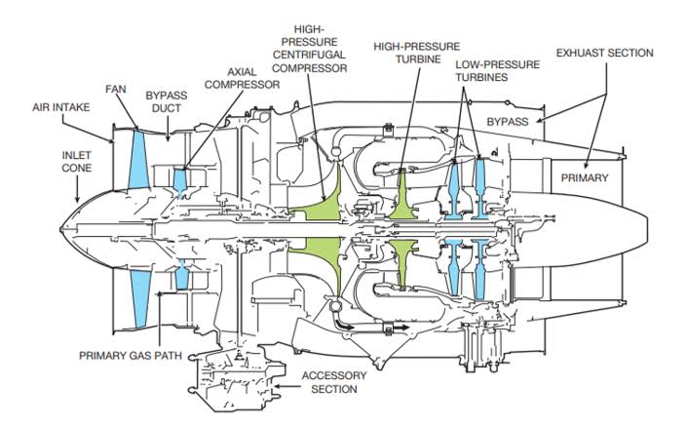

Figure*3.1. parts of a turbofan jet engine (Radtke, 2023)*

Figure 3.1 shows the working principle of a typical turbofan jet engine, showcasing its key components and the sequential process involved in generating thrust. At the front of the jet engine, the intake section plays an important role in accelerating incoming air, much like a propeller. A substantial part of this accelerated air bypasses the engine core which contributes to additional thrust thereby improving overall efficiency in the engine. However, some part of the air continues into the compressor section, where it is compressed by rapidly spinning blades. This compression process increases both the pressure and temperature of the air, preparing it for combustion. Inside the combustion chamber, the compressed air is then mixed with fuel and ignited, resulting in a high-energy combustion process. The expanding gases which were generated from combustion are then directed backwards into the turbine section, where spinning turbines extract enough energy to drive the compressor and power the engine. When all these are done, the combination of high-speed exhaust gases from the combustion process and the air bypassed from the fan section produces the total propulsion force which effectively generates thrust, allowing the aircraft to move forward with optimal efficiency.

## 3.1. THE DATASET

The dataset utilised for this experiment will be discussed in detail in this section. The dataset was collected from Kaggle, an online platform for machine learning datasets. The NASA Turbofan Jet Engine Data Set (Saxena *et al.,* 2008) is the Kaggle version of the public data set for asset degradation modelling from NASA. This dataset structure includes simulated data from turbofan jet engines which display a run-to-failure mode. This is because prognostics and health management are vital topics in the industry for predicting the state of machines to avoid wear and tear which could lead to failures. In this dataset, engine degradation simulation was carried out using C-MAPSS. Four different sets were simulated under different combinations of operational conditions and fault modes. Each data set is further divided into training and test subsets and represents a multivariate time series sensor. Each time-series data represents a different turbofan jet engine. Each engine starts with different degrees of initial wear and manufacturing variation which is unknown to the user. This wear and variation is considered normal, i.e., it is not considered a fault condition. In this data, three operational settings have a great effect on the performance of the engine. The engine operates normally at the start of each time series and develops a fault at some point during the series. One of the uses of this dataset is to predict the number of remaining useful life cycles before failure in the test set. Also, there is also a vector of true Remaining Useful Life (RUL) values provided for the test data. The four training datasets are FD001, FD002, FD003 and FD004 with one, one, two and two fault modes respectively. In this research, the datasets FD001 and FD004 were utilised for the determination of the remaining useful life.

## 3.2. DATA UNDERSTANDING

Before inference is done on any dataset involved in machine learning, the data must properly be understood and analysed. By doing so, the researchers draw valuable insights from the dataset to solve the given problem. The information on the dataset in section 3.1 is shown below in the Python environment in Figure 3.2.

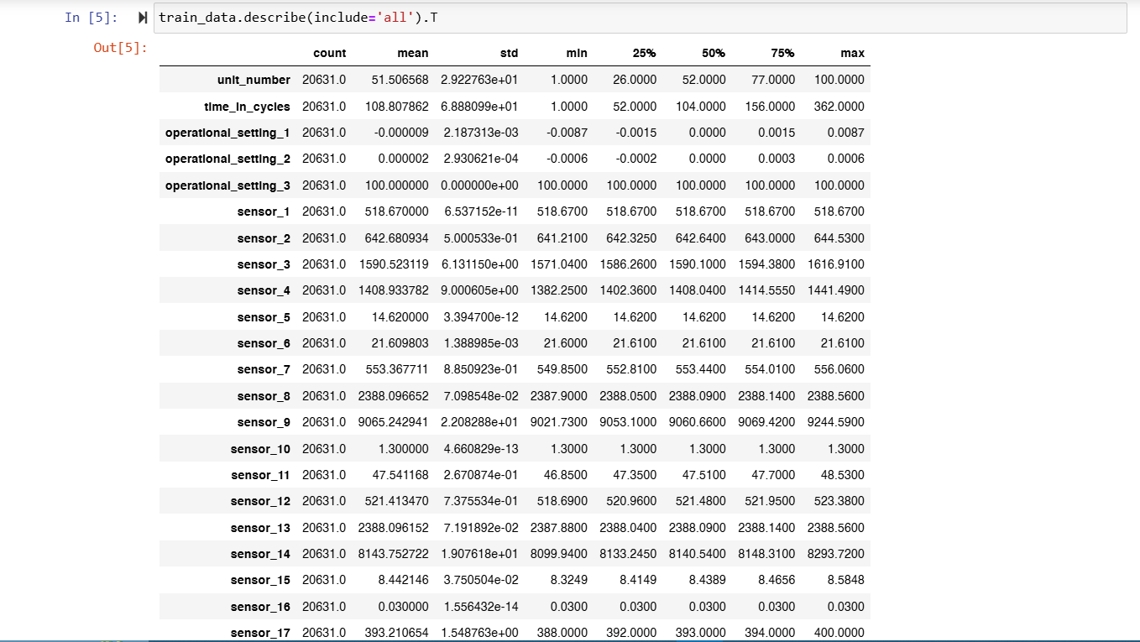

Figure*3.2. dataset insight*

## 3.3. DATA PREPROCESSING

In the preprocessing of a dataset, there are several methods which come to the mind of the researcher depending on the nature and attributes the dataset consists of. This dataset is a time series dataset which consists of several sensor data therefore preprocessing it needs to be done properly. Firstly, since there were no missing or null values in the dataset, there was no need to fill in any empty spaces. Also, since the RUL dataset and the train and test dataset were all distinct, there was a need to merge the train data, and the training RUL based on the time in cycles and the unit number. The dataset had a presence of noise in it which was not removed as that noise could contain some valuable information. The dataset had so many features which could result in a computation cost problem so there was a need to apply feature extraction on the dataset which reduced the features to the number of features which were relevant to the target variable. The method used to achieve this feature selection was the ordinary least square method from the stats model API using the p-value as the yardstick for selection. It is important to note that in this research, the FD001 and FD004 were the datasets utilised and had their performance compared against each other and the literature review. From the limitations in the previous literature, the data possessed some noises therefore our research went a step further to reduce the RMSE by introducing smoothing using EMA.

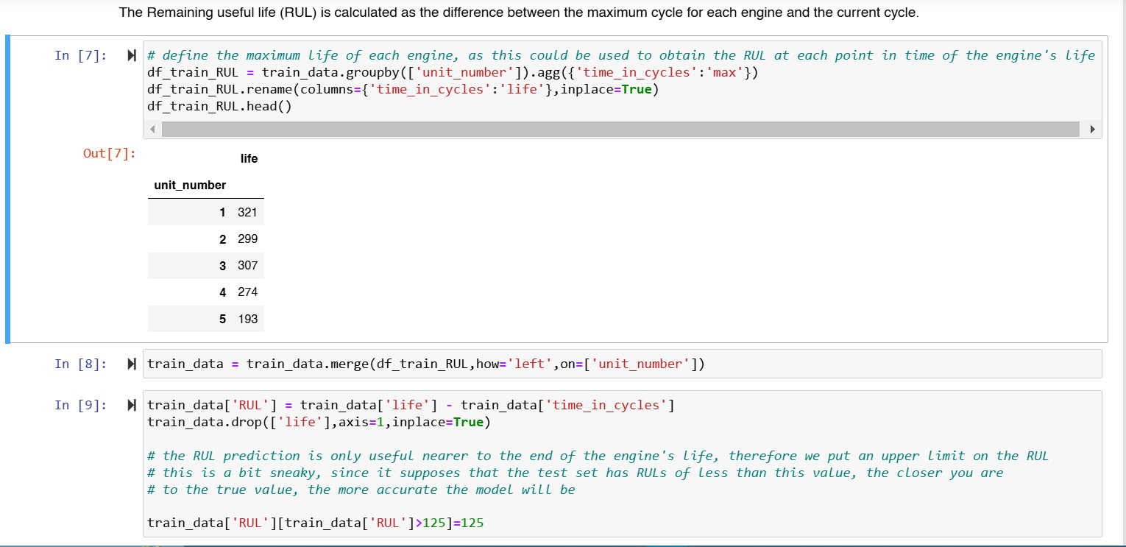

Figure*3.3: train RUL preprocessing*

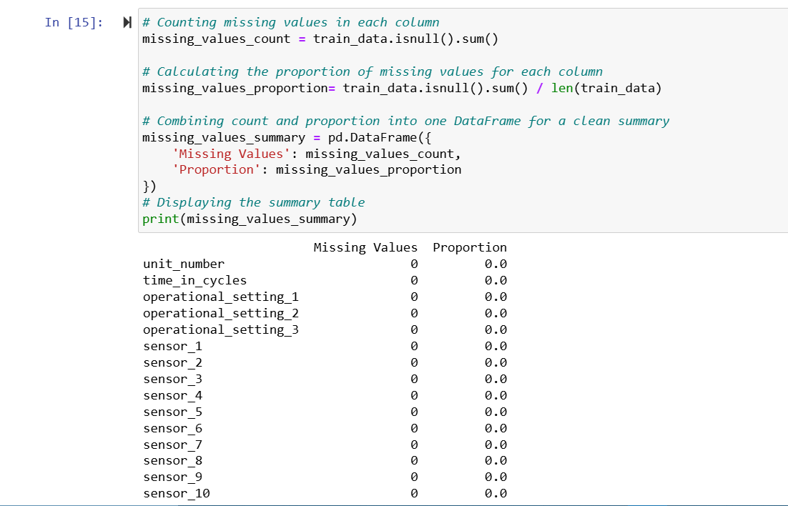

Figure*3.4: checking for missing values*

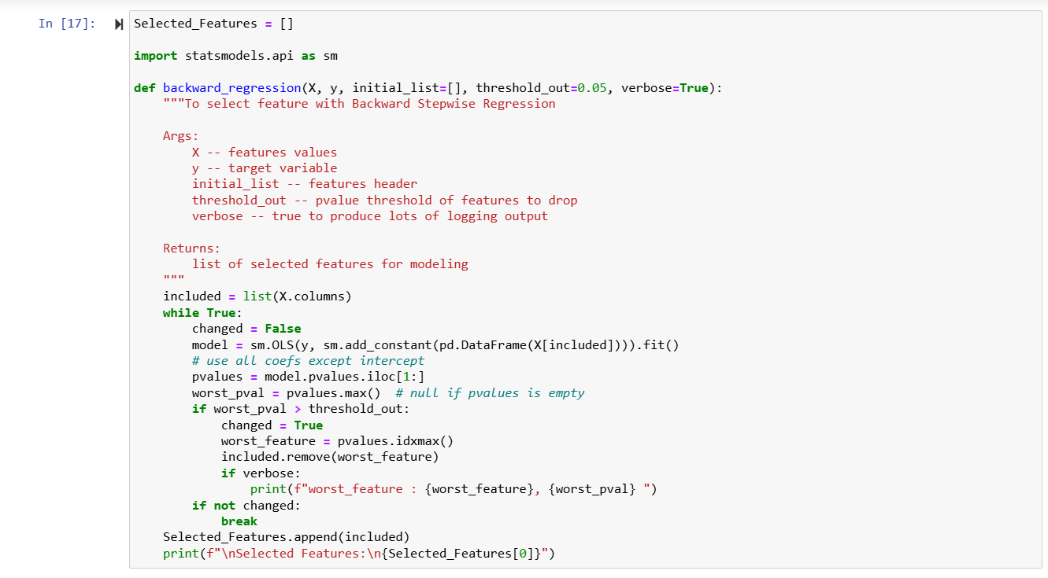

Figure*3.5: feature extraction*

## 3.4. DATA VISUALISATION

Data visualisation is a graphical representation of the features derived from another feature or present in each dataset. It makes the understanding of the data very easy visually for both technical and non-technical practitioners when looking at details in each research topic.

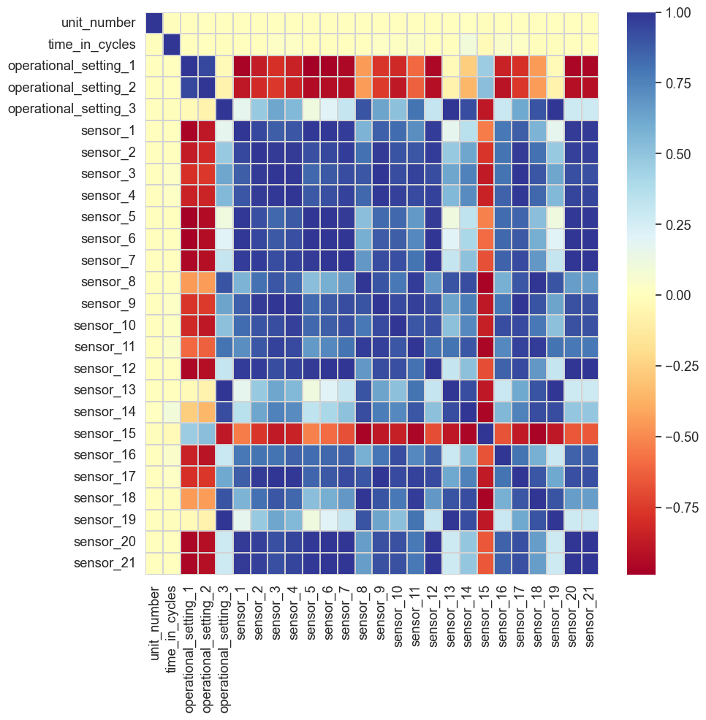

Figure*3.7. correlation matrix for FD004*

Figure 3.7 shows the relationships between different engine sensor readings, operational settings, and the time in cycles in the second dataset FD004. There are strong positive correlations indicating that certain sensors show highly similar behavior. Sensor pairs such as sensor_1 and sensor_2, or sensor_12 and sensor_13 show correlations above 0.9 showing that one can be used in place of the others which can help in feature selection by removing highly correlated sensors to avoid multicollinearity. Also, strong negative correlations show inverse relationships, where an increase in one sensor reading leads to a decrease in another, such as sensor_16 showing a negative correlation with time in cycles, which might indicate degradation trends over time. The operational settings also display correlations with multiple sensors, implying that engine operating conditions significantly influence sensor readings. Understanding these relationships is critical for predictive maintenance and Remaining Useful Life (RUL) estimation, as some sensors may serve as leading indicators of engine degradation while others may be redundant for modeling purposes.

## 3.5. DATA TRANSFORMATION

Data transformation is a crucial step in machine learning, ensuring that raw data is converted into a format suitable for model training. Since the CMAPSS dataset consists of telemetry sensor readings over time, it inherently contains noise, fluctuations, and outliers that can negatively impact model performance.

Key transformation steps applied in this study include:

* Standardisation (StandardScaler) – Ensuring all features have a mean of 0 and a standard deviation of 1 for consistency across models.
* Feature Selection (OLS method) – Using the Ordinary Least Squares (OLS) regression method to identify the most relevant sensor readings for Remaining Useful Life (RUL) prediction.
* Data Smoothing (Exponential Moving Average - EMA) – Addressing sensor noise and fluctuations in telemetry data.

One of the major limitations observed in previous research was the presence of noise in the CMAPSS dataset, which led to higher RMSE values in predictive models. To mitigate noise and improve model accuracy, this study introduced Exponential Moving Average (EMA) smoothing as a preprocessing technique. EMA is a time series smoothing technique that assigns exponentially decreasing weights to past observations, making recent values more significant while gradually reducing the impact of older data points. Unlike simple moving averages, EMA retains the memory of past values more dynamically, making it well-suited for time-series-based sensor data.

## 3.6. MACHINE LEARNING MODELS

The prediction of the Remaining Useful Life (RUL) of a turbofan jet engine is a very important task in the field of predictive maintenance, with the aim of estimating how long an engine would operate before it requires certain maintenance or replacement. Machine learning models play an important role in this field by utilising data, operational conditions, and failure patterns to predict this remaining life. This section talks about the machine learning models utilised in this research for the prediction of the remaining useful life of the turbofan jet engine.

## 3.6.1. LINEAR REGRESSION

This model is one of the basic and most widely employed statistical models for predictive modelling (Yan *et al.*, 2025). In the context of RUL prediction, sensor data and operational parameters are used as input features or independent variables (Menon and Tuladhar, 2024). The model estimates the remaining life by fitting a linear equation to the data used for training and minimises the difference between the predicted and actual RUL values using methods like the ordinary least squares. While this model is computationally efficient and easy to interpret, its simplicity can be a disadvantage when dealing with complex, non-linear data sets like jet engine data (Ullah, Younas and Saharudin, 2025). Despite its disadvantages, this model serves as a foundational baseline tool for most regression analysis (Elahi *et al.*, 2023). However, in real life, the degradation patterns of turbofan jet engines are often non-linear and are influenced by multiple interacting factors (Salvadori, Insinna and Martelli, 2024). The simplicity of this model makes it an important model for understanding the problem before the development of more sophisticated models (Aygül, Çırpan and Arslan, 2025).

## 3.6.2. RANDOM FOREST REGRESSOR

This is a powerful and versatile machine learning model used widely for regression analysis. This model is an ensemble learning method and it combines multiple decision trees to improve effective accuracy and at the same time aims to mitigate overfitting (Edozie *et al.*, 2025). Each decision tree in the random forest is trained on a random subset of data and features (Zhang, Lin and Gu, 2025). It aggregates predictions from all the decision trees to produce a final estimate for the remaining useful life. The ability of the random forest model to handle complex relationships between features makes it particularly well-suited for complex systems like turbofan jet engines (De Castro Cros, 2023). One of the strengths of the random forest regressor is its ability to handle high-dimensional and complex data, automatically identifying the most important features which reduce the need for extensive feature engineering (Kang, Kyritsis and Liatsis, 2025). This is a very useful tool in the prediction of the remaining useful life, where sensor data can be noisy. This model is not prone to overfitting compared to individual decision trees, due to the averaging effect of multiple trees. However, they can be computationally more expensive than smaller models, since they involve many trees. Despite these disadvantages, the random forest remains one of the best choices for most machine learning tasks due to its high accuracy (De La Iglesia *et al.*, 2025). It often serves as a strong benchmark for evaluating more advanced deep learning models.

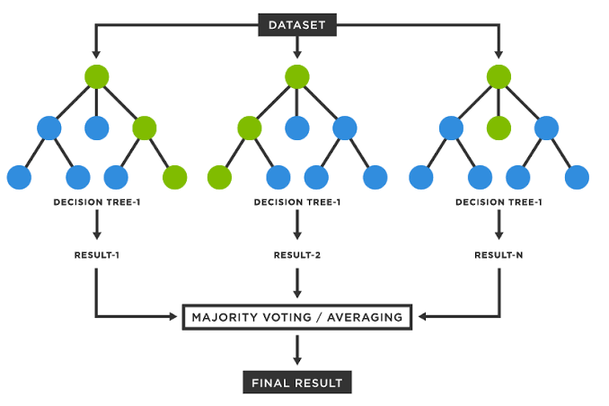

Figure*3.8: the random forest regressor (Kharkar, 2023)*

## 3.6.3. XGBOOST REGRESSOR

The XGBoost regressor (Extreme Gradient Boosting) is a very efficient and scalable machine learning algorithm. XGBoost is a more sophisticated implementation of the gradient boosting model, which creates an ensemble of decision trees in a sequential order, where each tree corrects the errors of the previous tree (Saraireh, Agoyi and Kassaymeh, 2025). This iterative approach allows this model to capture complex and non-linear relationships in any given data, making it particularly effective for RUL prediction which involves sensor data with noise (Mennilli, Mazza and Mura, 2025). One of the benefits of the XGBoost model is its low computational cost, which makes it efficient for handling large data commonly encountered in predictive maintenance applications (Edozie *et al.*, 2025). It also provides built-in support for feature extraction analysis which helps in identifying the most important features. Additionally, XGBoost offers flexibility through hyperparameter tuning, allowing users to optimise the model for specific tasks.

## 3.6.4. ARTIFICIAL NEURAL NETWORK (ANN)

Artificial Neural Networks (ANNs) are a form of machine learning models inspired from the structure of biological neural networks in the human brain (Osman and Mohamed, 2024). This model consists of layers of interconnected nodes which are known as neurons. These neurons include an input layer for sensor data and operational parameters which are the input features and one or more hidden layers to capture the complex patterns and an output layer for prediction (Ali and Kamal, 2025). Each neuron in the model applies a weighted sum of inputs followed by an activation function, usually a rectified linear unit (Relu) which allows the network to learn complex representations of the data (Taha, 2025). This makes ANNs highly effective for capturing the complex degradation patterns of jet engines, which often involve interactions between multiple sensor data and operational conditions. One of the advantages of the ANN is its adaptability to various types of data of all ranges. However, these neural networks typically require a large volume of data and computational resources to achieve a good performance. They are also prone to overfitting if not regularised properly (Jain *et al.*, 2025). Despite these disadvantages, ANNs have demonstrated good performance in many predictive maintenance tasks, particularly when combined with tuning techniques like dropout and batch normalisation (Himeur *et al.*, 2022). Their ability to learn complex patterns and adapt to datasets makes them a powerful tool for predictive maintenance in aerospace and other industries.

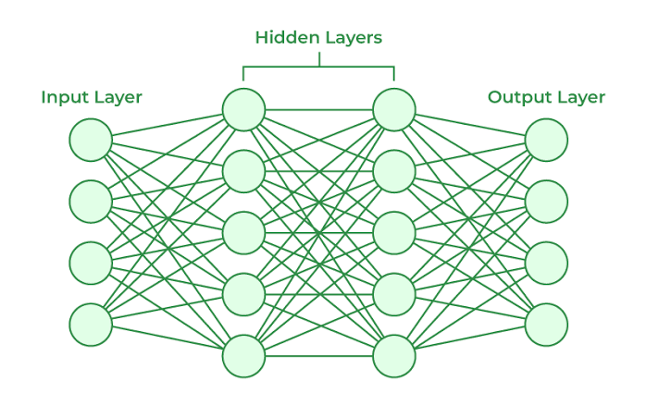

Figure*3.9. the artificial neural network (GeeksforGeeks, 2024)*

## 3.6.5. CONVOLUTIONAL NEURAL NETWORK (CNN)

Convolutional Neural Networks (CNNs) are a special type of artificial neural network (ANN) which were designed to process structured data, such as image data (Saeidnia *et al.*, 2025). While used mainly for tasks involving computer vision only, CNNs have proven highly effective in the field of predictive maintenance, especially when sensor data is treated as a 1D or 2D signal (Zhang *et al.*, 2024). CNNs leverage convolutional layers to automatically extract patterns and features from the data. These features are then passed through fully connected layers for prediction. By utilising filters known as kernels which slide over the data, the CNN model can capture spatial or temporal dependencies, making them useful for analysing time-series sensor data from turbofan jet engines, where degradation patterns often manifest as localised changes over time. One of the key advantages of these models is their ability to perform automatic feature extraction which reduces the need for manual feature engineering (Chen *et al.*, 2025). CNNs also have additional layers known as pooling layers, which downsample the extracted features, making the model more computationally efficient (Sajid *et al.*, 2025). However, they typically need a large amount of data to achieve optimal performance and can be computationally expensive to train. Despite these limitations, this model has shown remarkable success in predictive maintenance tasks when combined with techniques like transfer learning.

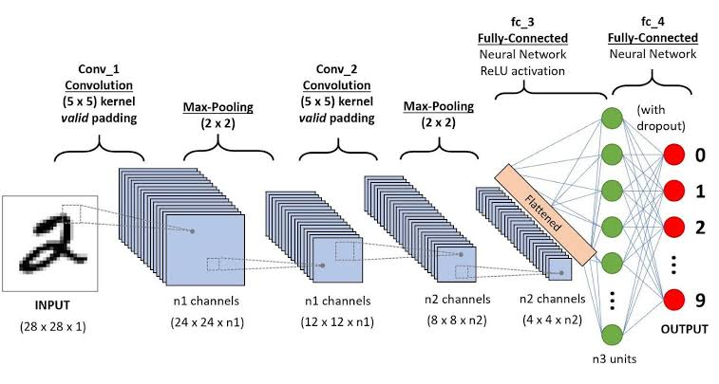

Figure*3.10: Convolutional neural network (Dandekar, 2023)*

## 3.6.6. LONG SHORT TERM MEMORY (LSTM)

The long short term memory (LSTM) is a variant of the recurrent neural network (RNN) which was created to tackle the limitations of the RNNs, that is the problem related to vanishing or exploding gradients (Hewamalage, Bergmeir and Bandara, 2020). This model possesses a unique kind of architecture which incorporates memory cells and gating mechanisms to manage the flow of information effectively. In each LSTM cell, there are three gates: the input gate which decides how much of the new input to store in the cell state, the forget gate which determines which information to dispose of in the cell and the output gate, which controls how much information from the cell state is passed to the output (Aswanuwath *et al.*, 2023). These gates work hand in hand to selectively retain or update information over time, enabling the network to remember vital information while discarding any information deemed unnecessary. This makes the LSTM very useful in long term dependent learning such as time series, language modeling and speech recognition.

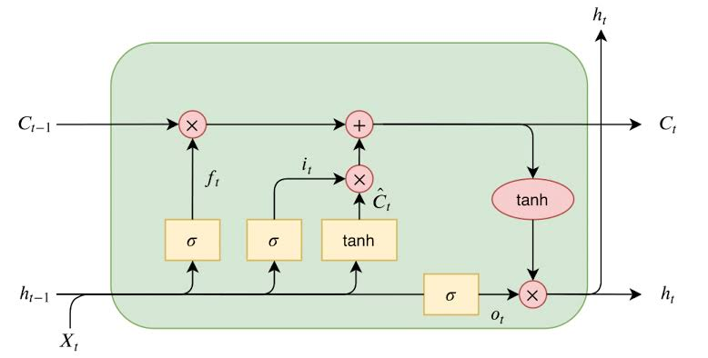

Figure*3.11: long short term memory (LSTM) (Hesaraki, 2023)*

## 3.7. EVALUATION METRICS

After the model training and testing phase during the experiment, some statistical methods were employed to evaluate the performance of the machine learning and deep learning models. In this research, the RMSE was the main metric of performance for the models since that’s the main metric in the literature review section. Evaluation of a regression model is an important step in determining how well the model predicts continuous numerical outcomes. Unlike classification models, which are evaluated using accuracy or precision, regression models require different statistical metrics which measure the difference between predicted and actual values. In this research, the r2 score and the mean square error were the main metrics of performance. The choice of the utilisation of these metrics is because MSE and RMSE highlight the large errors in a model, which is useful if the priority is avoiding mistakes, MAE provides a more balanced measure which gives equal weight to all the errors and finally, RMSE is used in practical applications because it provides an error estimate in the same unit as the dependent variable. Using multiple metrics in a machine learning project helps in gaining an in-depth understanding of how different models perform in different environments.

Table*3.1: evaluation metrics*

|  |  |
| --- | --- |
| METRICS | FORMULA |
| Mean square error |  |
| Mean absolute error |  |
| R2 score | 1 - |

Where:

* RSS = sum of squares of residuals
* TSS = total sum of squares
* yi = prediction
* xi = true value
* n = total number of data points

# 4.0. EXPERIMENT AND RESULTS

This section provides a comprehensive assessment of all the experimental results conducted throughout this research. The experiments were executed systematically, starting from the initial data preprocessing stage, which involved cleaning, transforming, feature engineering and organising the data to ensure its suitability. All experimental procedures were carried out within the Jupyter Notebook integrated development environment (IDE), a versatile and widely used platform for data analysis, machine learning and visualisation. The Jupyter Notebook was accessed as part of the Anaconda distribution, a powerful online tool specifically designed for data analytics and scientific computing offering a wide environment of libraries and packages tailored for machine learning and data analysis. The research primarily utilised the Python programming language, leveraging its extensive libraries such as Pandas for the manipulation of data, NumPy for numerical computations, Matplotlib and Seaborn for visualisation of data, Scikit-learn and TensorFlow for implementing machine learning and deep learning algorithms. Each experiment was meticulously documented to ensure reproducibility, with detailed explanations of the methodologies and outcomes provided.

## 4.1. MODEL TRAINING

Before commencing the machine learning and deep learning models training with the preprocessed trained dataset, the engine sensors were visualised to show the noise within each operational unit during the runtime of the machine. This visualisation helps to provide important information about the health and performance of the turbofan jet engine. These sensor noises represent variations or irregularities in the data collected by sensors and can reveal underlying issues such as mechanical wear, component degradation, or anomalies in the engine's operation. Additionally, these visualisations help in differentiating between normal operational noise and abnormal noise that could signal critical faults. For example, sudden spikes and unusual patterns in the noise data might point to specific components, such as fan blades that require maintenance or replacement. This approach enables predictive maintenance, reducing the risk of unexpected engine failures. The machine learning models utilised were random forest regressor, extreme gradient boosting, and linear regression while the two deep learning architectures were artificial neural network (ANN) and convolutional neural network (CNN). After the training and testing of the models, they were evaluated using the performance evaluation metrics discussed in section 3.7.

## 4.2. MODEL EVALUATION

For the machine learning and deep learning models developed for the first dataset FD001 of the turbofan jet engine remaining useful life, the general models performed well on training and evaluation, with the machine learning model XGBoost regressor being the best-performing models with 0.38 RMSE. After the XGBoost regressor, the random forest regressor was the next best performing model with a RMSE of 0.57. In the general modeling of the remaining useful life in this dataset, the whole machine and deep learning models performed relatively well with an RMSE of under 6.0 with LSTM being the worst model with an RMSE of 5.05. For the modelling of the second dataset FD004, the random forest regressor was the best-performing model with an RMSE score of 0.31 followed by XGBoost as the second-best model with a score of 1.03. Also, generally, the models in this dataset analysis performed well with an RMSE score below 6.0 with the LSTM being the worst-performing model with a score of 5.43. From this research in the first dataset FD001, the classical machine learning models were better suited for the prediction of the remaining useful life (RUL) than the deep learning models which will be explained in the next paragraph.

In this research, it was observed that the convolutional neural network (CNN) was utilised and being an image model, it can also be used in certain scenarios particularly when dealing with structured data or sequence data like time series as it can capture local dependencies like faults, vibration, pressure without much feature engineering. Also, it can be seen that the LSTM and hybrid models performed relatively lower than the other proposed models in the research and the reason is that classical machine learning models are better suited for structured and tabular data, LSTM is sensitive to noise so if the data contains fluctuations they might not learn meaningfully and as per the hybrid model, although CNN works well with the extraction of local patterns, they may struggle with long-term dependencies in time series data. The hybrid model may have focused too much on spatial feature extraction and not enough on the sequential nature of the remaining useful life (RUL) trends.

## 4.3. RESULT COMPARISON TO LITERATURE REVIEW

From the literature review, most of the data utilised was mainly the CMAPSS dataset which was also the dataset utilised in this research. From the limitations of the reviewed studies, it can be seen that the authors stated a limitation in their research being a result of the lack of noise filtering and handling and also limited use of model implementation so that was why in this research, 6 different models and a hybrid model were proposed. The first step to further the literature was the implementation of 7 different distinct models in which a model hyperparameter tuning was carried out on the hybrid model for better results. Most of the reviewed papers made use of RMSE as their baseline evaluation metric so we can compare our results based on that metric for the regression models. In general, the random forest regressor and the XGBoost regressor amongst the proposed models in this research seem to be the best-performing machine learning model across the research development with RMSE of 0.31 and 0.38 respectively after smoothing and noise removal were implemented in both dataset analysis. The RMSE of the best models across the reviewed table was not less than 3.3 for another dataset and 11.0 on this CMAPSS dataset but in this research, we have attained a very low RMSE of both 0.31 and 0.38 which makes this research a success as it exceeds the performance of other previously proposed detection models. It is crucial to note that even the worst-performing proposed model in this research exceeds the best model for research with the proposed dataset in the review section hence, we can conclude by saying that our research aim and objectives have been achieved.

Table*4.1: results from the first dataset FD001*

|  |  |  |  |
| --- | --- | --- | --- |
| MODEL | MSE | RMSE | MAE |
| LINEAR REGRESSION | 2.19 | 1.48 | 0.80 |
| RANDOM FOREST | 0.33 | 0.57 | 0.02 |
| XGBOOST | 0.14 | 0.38 | 0.01 |
| ANN | 2.65 | 1.63 | 0.99 |
| CNN | 13.96 | 3.74 | 2.50 |
| LSTM | 25.52 | 5.05 | 4.02 |
| HYBRID MODEL | 2.59 | 1.61 | 1.11 |

Table*4.2*: *results from the second dataset FD004*

|  |  |  |  |
| --- | --- | --- | --- |
| MODEL | MSE | RMSE | MAE |
| LINEAR REGRESSION | 3.71 | 1.93 | 0.87 |
| RANDOM FOREST | 0.10 | 0.31 | 0.01 |
| XGBOOST | 1.05 | 1.03 | 0.08 |
| ANN | 2.77 | 1.66 | 0.84 |
| CNN | 4.50 | 2.12 | 1.37 |
| LSTM | 29.54 | 5.43 | 4.63 |
| HYBRID MODEL | 3.45 | 1.86 | 1.09 |

## 4.4. RESULT VISUALISATION FOR THE PROPOSED DATASETS SHOWING THE ACTUAL AND PREDICTED VALUES

The outputs for the regression results for the machine learning, deep learning and hybrid models will be shown in this section. It shows the true versus predicted sensor readings for the Linear Regression, random forest, XGBoost, ANN, CNN and the hybrid model.

## 4.4.1. RESULTS FOR DATASET 1 (FD 001)

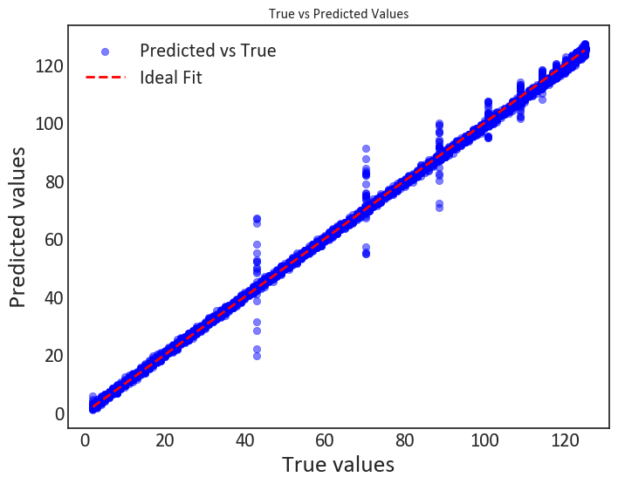

Figure*4.1: Showing the true and predicted values of Linear regression*

Figure 4.1 shows the relationship between the true Remaining Useful Life (RUL) of an engine and the predicted Remaining Useful Life (RUL) based on sensor data for a logistic regression model on the first dataset. The close positioning of most of the data points with the line of best fit indicates that the logistic regression model effectively captures the degradation patterns of the engine using sensor signals. However, the presence of outliers at certain RUL values shows that some sensor readings may not fully capture the nonlinear interactions affecting the engine health which could be due to sensor noise or variations in operating conditions influencing the prediction of the RUL.

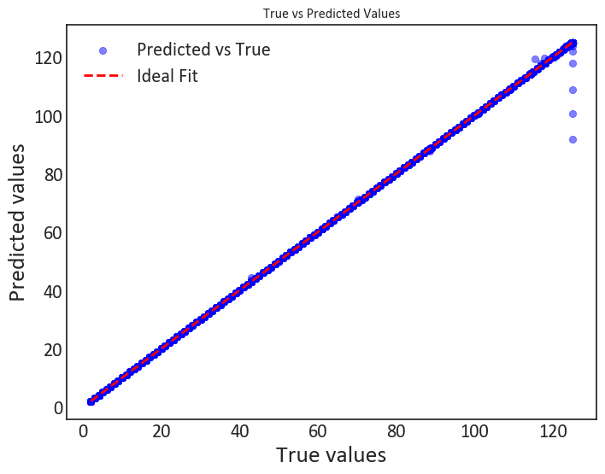

Figure*4.2: Showing the true and predicted values of random forest*

Figure 4.2 shows the relationship between the actual and predicted values of the random forest model. This result shows a strong predictive performance of the model in estimating the Remaining Useful Life (RUL) of the engine based on sensor signals. The near-perfect fitting of predicted values suggests that the model has successfully captured the underlying relationships between sensor readings and engine degradation patterns. The small deviations observed at higher RUL values may indicate minor inaccuracies in the model’s ability to generalise to extreme conditions.

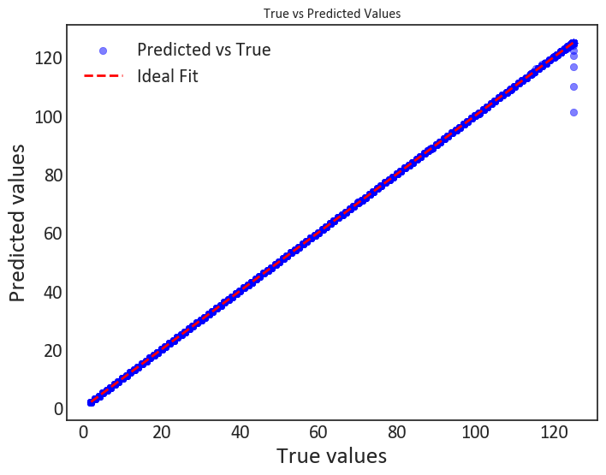

Figure*4.3: Showing the true and predicted values of XGboost*

This result in figure 4.3 demonstrates the actual and predicted values of the XGBoost model for the prediction of the remaining useful life. The strong alignment between predicted and true values along the best fit line indicates that the selected sensor features effectively capture engine degradation patterns. This indicates that the model is using meaningful correlations between sensor readings to estimate RUL with minimal error.

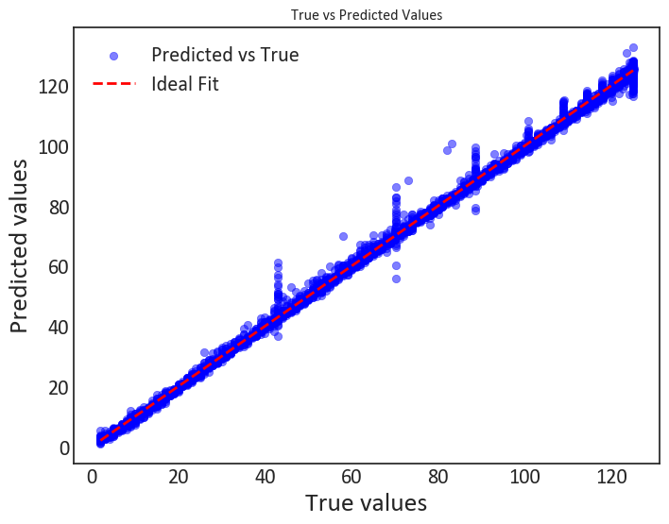

Figure*4.4: Showing the true and predicted values of Artificial neural network*

Figure 4.4 shows the result from the ANN used in detecting the Remaining Useful Life (RUL). From this image, it indicates that the model has captured the basic relationships between engine sensor signals and the Remaining Useful Life (RUL) with a high degree of accuracy but with some level of variability. The alignment along the best fit line suggests that the model successfully interprets sensor data to predict engine degradation trends. However, the increased spread at higher RUL values points to some inconsistencies such as sensor noise.

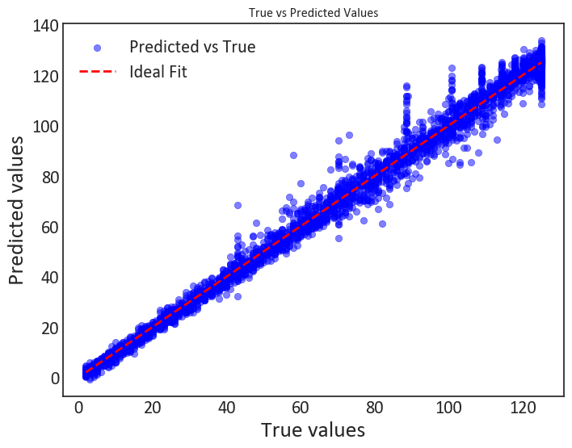

Figure*4.5: Showing the true and predicted values of convolutional neural network*

Figure 4.5 shows the correlation between the true and the predicted RUL of a turbofan jet engine from sensor data using a convolutional neural network. The strong synchronisation along the best-fit line indicates that the model effectively captures the degradation trends. The relatively small deviations around the line of best fit indicate that the sensor data provide meaningful insights into the engine’s health status, allowing for reliable RUL estimation. However, the outliers, particularly at certain RUL values, may indicate sensor noise or untreated external factors that the model does not fully capture.

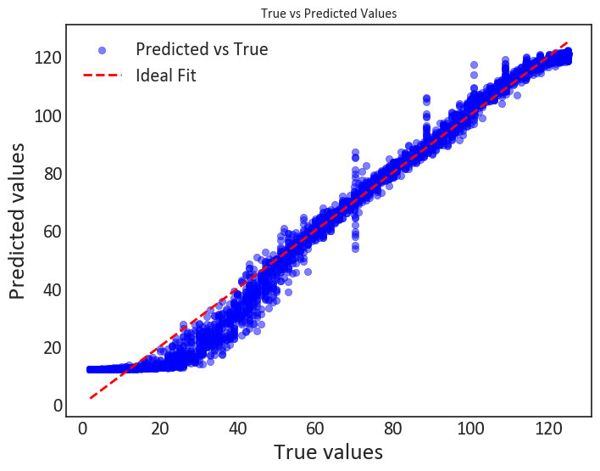

Figure*4.6: Showing the true and predicted values of LSTM*

The scatter plot in figure 4.6 above represents the relationship between the true and predicted RUL values of a turbofan jet engine based on sensor signals from a LSTM model. The general alignment of predictions with the line of best fit shows that the model captures vital sensor trends related to the degradation of the engine. But observations from the deviations at lower RUL values suggest potential underestimation of failure progression, which may indicate that certain sensor signals are not fully capturing rapid wear and tear which could be a problem from the foundational setup of a LSTM model. Also, the slight curve in the lower range indicates that the model may struggle with early-stage degradation patterns.

## 4.4.2. RESULTS FOR DATASET 2 (FD 004)

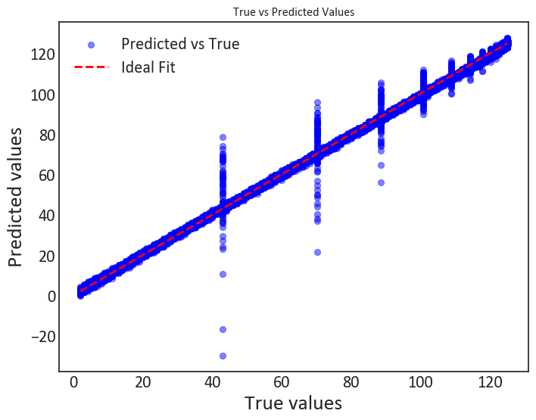

Figure*4.7: Showing the true and predicted values of Logistic regression*

The scatter plot in figure 4.7 shows the relationship between the true Remaining Useful Life (RUL) of an engine and the predicted Remaining Useful Life (RUL) based on sensor data for a logistic regression model. The close alignment of most of the data points with the line of best fit suggests that the logistic regression model effectively captures the degradation patterns of the engine using sensor signals. However, the presence of outliers at certain RUL values indicates that some sensor readings may not fully capture the nonlinear or complex interactions affecting engine health which could be due to sensor noise, variations in operating conditions, or unaccounted external factors influencing RUL predictions.

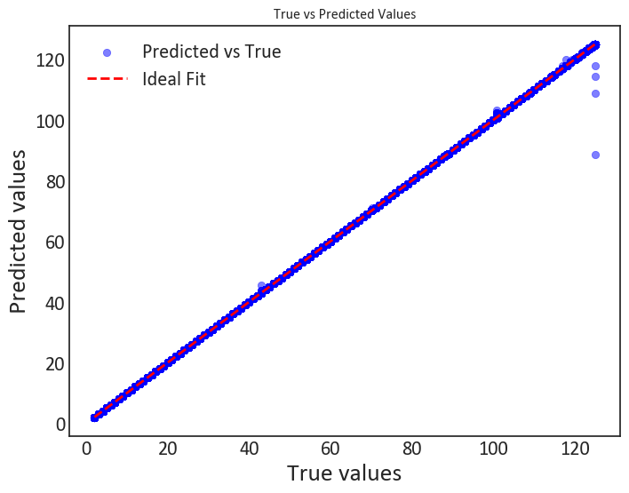

Figure*4.8: Showing the true and predicted values of random forest*

Figure 4.8 shows the relationship between the actual and predicted values of the random forest model showing a strong performance of the model. The near-perfect fitting of predicted values suggests that the model has successfully captured the underlying relationships between sensor readings and engine degradation patterns. The small deviations observed at higher RUL values may indicate minor inaccuracies in the model’s ability to generalise to extreme conditions.

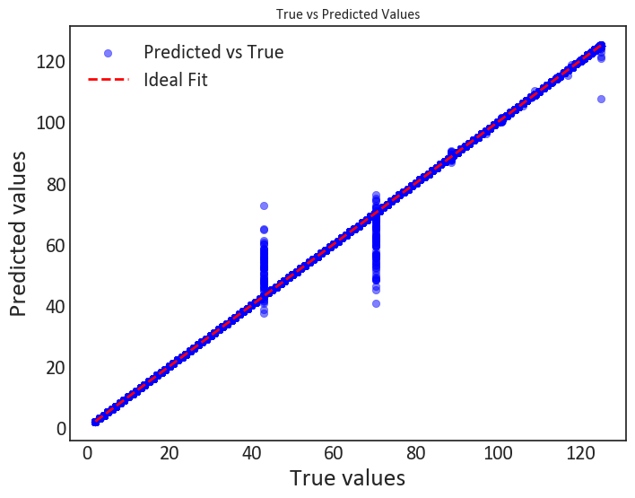

Figure*4.9: Showing the true and predicted values of XGboost*

Figure 4.9 shows the relationship between the actual and predicted values in the detection of RUL. The model shows a good generalisation as seen in the correlation in the line of best fit but the presence of vertical clusters of predictions at certain RUL values suggests that the model may struggle with differentiating between similar sensor signal patterns, leading to discrete prediction groupings rather than continuous estimations. This could be due to limitations in feature representation, insufficient training data diversity, or an inherent bias in the dataset.

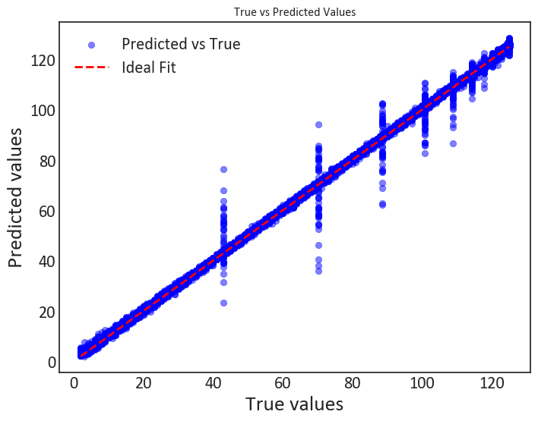

Figure*4.10: Showing the true and predicted values of artificial neural network*

Figure 4.10 suggests that the artificial neural network effectively captured the relationship between engine sensor signals and the Remaining Useful Life (RUL). However, the dispersion of predicted values at specific points suggests that the model exhibits some degree of uncertainty or bias when predicting certain RUL ranges. This clustering effect might be due to limited variability in sensor signals. While the model performs well overall, further improvements could enhance its predictive stability.

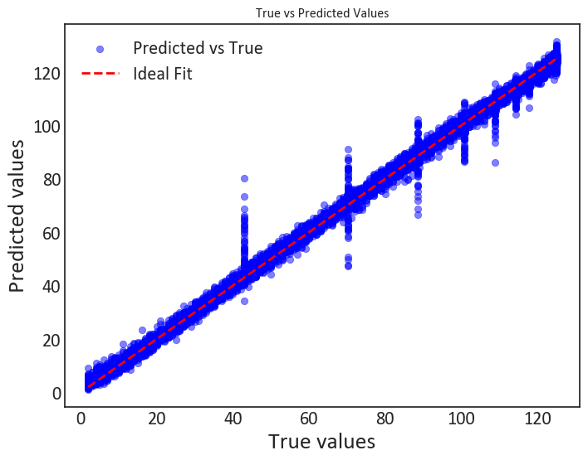

Figure*4.11: Showing the true and predicted values of convolutional neural network*

The scatter plot in figure 4.11 shows the correlation between the true Remaining Useful Life (RUL) and the predicted RUL of an engine based on sensor data using a convolutional neural network. The strong fit along the best fit line indicates that the model effectively captures the degradation trends of the engine by using signals from sensors. The relatively small diversion around the best fit line indicates that the sensor data provides meaningful information on the engine’s health status. But there are presence of the outliers at certain RUL values which may indicate sensor noise or untreated external factors that the model does not fully capture.

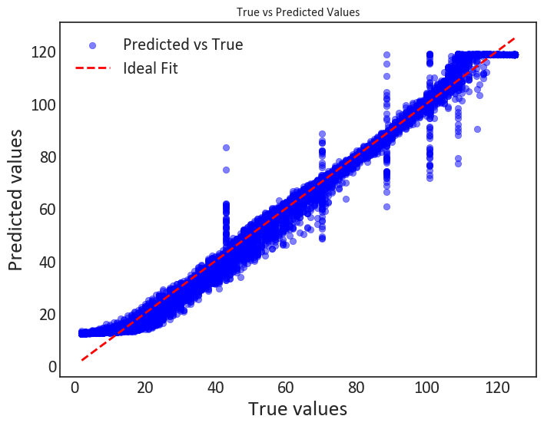

Figure*4.12: Showing the true and predicted values of LSTM*

The scatter plot in figure 4.12 represents the relationship between the true and predicted Remaining Useful Life (RUL) of an engine based on sensor signals from a LSTM model. The overall alignment of predictions with the ideal fit line indicates that the model captures key sensor trends related to engine degradation. But observations from the deviations at lower RUL values suggest potential underestimation of failure progression, which may indicate that certain sensor signals are not fully capturing rapid wear and tear. Also, the slight curve in the lower range indicates that the model may struggle with early-stage degradation patterns.

The outliers in the model prediction are due to the noise in the sensor data. Over smoothening of the data would lead to overfitting of the data with the best fit line hence the remaining noise in the data which is in small amounts are seen as the data points deviation or outliers during the prediction.

## 4.5. KEY FINDINGS

1. Random Forest (FD004) and XGBoost (FD001) outperformed all other models, demonstrating superior accuracy in predictive maintenance tasks.
2. Classical machine learning models performed better than deep learning models, likely due to the structured/tabular nature of the dataset. The CMAPSS dataset with sensor readings behaving independently at each time step, lacks strong sequential dependencies which LSTMs rely on. This made decision-tree models like Random Forest and XGBoost more effective, as they excel in structured/tabular data analysis.
3. EMA smoothing significantly improved RMSE values, proving to be a crucial step in handling sensor noise. While EMA smoothing helped reduce some noise, LSTMs are highly sensitive to noise and fluctuations in sensor readings and tend to retain past errors, leading to compounding inaccuracies over time. In contrast, tree-based models are naturally robust to noisy data, allowing them to generalise better. Additionally, deep learning models like LSTM require large datasets to perform well. The CMAPSS dataset, though extensive, is relatively small for deep learning needs.

# 5.0. CONCLUSION

This research was proposed to predict the remaining useful life using a telemetry sensor dataset obtained from Kaggle known as the CMAPSS dataset which could help aircraft manufacturers manage their aircraft engine business that could lead to fuel optimisation and knowledge of the estimated time an engine would likely fail. The research objectives include the design and implementation of machine and deep learning models for prediction, determining the most effective model, utilisation of two of the four datasets in the CMAPSS folder, evaluation of the models based on statistical measures and finally, the introduction of noise smoothing which was a major limitation in the reviewed papers section. Insights from the results of the various machine and deep learning models that were implemented and evaluated, it can be concluded that for the prediction of remaining useful life, the random forest regressor and the XGBoost regressor are the best regression models achieving the least RMSE of 0.31 and 0.38 respectively, while the worst performing model as observed in this experiment was the LSTM with a RMSE of 5.05 and 5.43 for dataset FD001 and FD004 respectively.

## 5.1. LIMITATIONS AND FUTURE RECOMMENDATIONS

The findings in this research contribute to the general goal of trying different kinds of machine learning and deep learning models in the field of telemetry, mainly in the aspect of aircraft turbofan jet engines which solve different practical problems with an emphasis on model performances. It is important to note that the models proposed in this research can only be tailored to sensor data based on the features presented in this research proposed dataset. A major drawback in this research is the issue of data splitting which can lead to several inconsistencies especially when dealing with issues as delicate to telemetry data, but from this research, we can see the effect of the train test splitting technique, provided by the Sklearn library which handles it efficiently, also the use of python for data cleaning and manipulation. Also, other drawbacks encountered in this research, such as the issue of computational cost when training the employed deep learning models. Another major limitation encountered in this research is the issue of domain knowledge, as the application of certain preprocessing steps for sensor data with respect to turbofan jet engines becomes a necessity which not every professional data scientist has. Lastly, the issue of the noise in the dataset which initially made the RMSE of the models to be high was a big limitation, but it was solved using the implementation of the exponential moving average (EMA) smoothing technique.

In future studies, it would be beneficial to utilise Graphics Processing Unit (GPU) computational training resources such as the NVIDIA RTX computer system. Finally, the experiment results show that the random forest and XGBoost regressor performed well on the sensor data after the noise signal smoothing was implemented on the dataset. However, it is important to note that the deep learning models also performed very well in comparison with the best models.

# 

# REFERENCE

A. Saxena, K. Goebel, D. Simon, and N. Eklund, Damage Propagation Modeling for Aircraft Engine Run-to-Failure Simulation, in the Proceedings of the 1st International Conference on Prognostics and Health Management (PHM08), Denver CO, Oct 2008.

Ahmed, S.F. *et al.* (2023) 'Deep learning modelling techniques: current progress, applications, advantages, and challenges,' *Artificial Intelligence Review*, 56(11), pp. 13521–13617.

Al-Khazraji, H., Nasser, A.R., Hasan, A.M., Al Mhdawi, A.K., Al-Raweshidy, H. and Humaidi, A.J., 2022. Aircraft engines remaining useful life prediction based on a hybrid model of autoencoder and deep belief network. IEEE Access, 10, pp.82156-82163.

Ali, A.R. and Kamal, H. (2025) 'Time-to-Fault prediction Framework for automated manufacturing in humanoid robotics using Deep Learning,' *Technologies*, 13(2), p. 42.

Amir, M. *et al.* (2023) 'Energy storage technologies: An integrated survey of developments, global economical/environmental effects, optimal scheduling model, and sustainable adaptation policies,' *Journal of Energy Storage*, 72, p. 108694.

Andresini, G., Appice, A. and Malerba, D. (2021) 'Autoencoder-based deep metric learning for network intrusion detection,' *Information Sciences*, 569, pp. 706–727.

Apeiranthitis, S. *et al.* (2024) 'Predictive Maintenance of Machinery with Rotating Parts Using Convolutional Neural Networks,' *Electronics*, 13(2), p. 460.

Aswanuwath, L. *et al.* (2023) 'An Improved Hybrid Approach for Daily Electricity Peak Demand Forecasting during Disrupted Situations: A Case Study of COVID-19 Impact in Thailand,' *Energies*, 17(1), p. 78.

Aygül, M.A., Çırpan, H.A. and Arslan, H. (2025) 'Machine learning-based spectrum occupancy prediction: a comprehensive survey,' *Frontiers in Communications and Networks*, 6.

Baduge, S.K. *et al.* (2022) 'Artificial intelligence and smart vision for building and construction 4.0: Machine and deep learning methods and applications,' *Automation in Construction*, 141, p. 104440.

Borisov, V. *et al.* (2022) 'Deep Neural Networks and Tabular Data: A survey,' *IEEE Transactions on Neural Networks and Learning Systems*, 35(6), pp. 7499–7519.

Budhwar, P. *et al.* (2023b) 'Human resource management in the age of generative artificial intelligence: Perspectives and research directions on ChatGPT,' *Human Resource Management Journal*, 33(3), pp. 606–659.

Chen, H. *et al.* (2025) 'Comprehensive exploration of diffusion models in image generation: a survey,' *Artificial Intelligence Review*, 58(4).

Cummins, L. *et al.* (2024) 'Explainable Predictive Maintenance: a survey of current methods, challenges and opportunities,' *IEEE Access*, 12, pp. 57574–57602.

Dandekar, I. (2023) 'Introduction to Convolutional Neural Networks: Part 1,' *Medium*, 13 February.

De Castro Cros, M. (2023) *DA&AI supporting tools for gas turbine’s efficiency improvement: maintenance, operation modes and performance enhancement*.

De La Iglesia, D.H. *et al.* (2025) 'Advanced Machine Learning and Deep Learning Approaches for Estimating the Remaining Life of EV Batteries—A Review,' *Batteries*, 11(1), p. 17.

Deng, S. and Zhou, J., 2024. Prediction of remaining useful life of aero-engines based on CNN-LSTM-Attention. International Journal of Computational Intelligence Systems, 17(1), p.232.

Deutsch, J. and He, D., 2017. Using a deep learning-based approach to predict remaining useful life of rotating components. IEEE Transactions on Systems, Man, and Cybernetics: Systems, 48(1), pp.11-20.

Dhanaraju, M. *et al.* (2022) 'Smart Farming: Internet of Things (IoT)-Based Sustainable agriculture,' *Agriculture*, 12(10), p. 1745.

Edozie, E. *et al.* (2025) 'Artificial intelligence advances in anomaly detection for telecom networks,' *Artificial Intelligence Review*, 58(4).

Elahi, M. *et al.* (2023) 'A comprehensive literature review of the applications of AI techniques through the lifecycle of industrial equipment,' *Discover Artificial Intelligence*, 3(1).

Friederich, J. and Lazarova-Molnar, S. (2023) 'Reliability assessment of manufacturing systems: A comprehensive overview, challenges and opportunities,' *Journal of Manufacturing Systems*, 72, pp. 38–58.

GeeksforGeeks. (2024, August 7). *Artificial Neural Networks and its Applications*. GeeksforGeeks.

Hewamalage, H., Bergmeir, C. and Bandara, K. (2020) 'Recurrent Neural Networks for Time Series Forecasting: Current status and future directions,' *International Journal of Forecasting*, 37(1), pp. 388–427.

Herteux, J. *et al.* (2024) 'Forecasting trends in food security with real time data,' *Communications Earth & Environment*, 5(1).

Hesaraki, S. (2023) 'Long Short-Term Memory (LSTM) - Saba Hesaraki - Medium,' *Medium*, 27 October.

Himeur, Y. *et al.* (2022) 'Next-generation energy systems for sustainable smart cities: Roles of transfer learning,' *Sustainable Cities and Society*, 85, p. 104059.

Jain, R. *et al.* (2025) 'Data-Driven Civil Engineering: applications of artificial intelligence, machine learning, and deep learning,' *Turkish Journal of Engineering*, 9(2), pp. 354–377.

Kanawaday, A. and Sane, A., 2017, November. Machine learning for predictive maintenance of industrial machines using IoT sensor data. In 2017 8th IEEE international conference on software engineering and service science (ICSESS) (pp. 87-90). IEEE.

Kang, R., Kyritsis, D.C. and Liatsis, P. (2025) 'Comparative analysis of data-driven models for spatially resolved thermometry using emission spectroscopy,' *PLoS ONE*, 20(1), p. e0317703.

Kang, Z., Catal, C. and Tekinerdogan, B., 2021. Remaining useful life (RUL) prediction of equipment in production lines using artificial neural networks. Sensors, 21(3), p.932.

Kautz, H.A. (2022) 'The third AI summer: AAAI Robert S. Engelmore Memorial Lecture,' *AI Magazine*, 43(1), pp. 105–125.

Kharkar, D. (2023, July 9). About Random Forest Algorithms. - Dishant kharkar - Medium. *Medium*.

Lee, J. and Mitici, M., 2023. Deep reinforcement learning for predictive aircraft maintenance using probabilistic remaining-useful-life prognostics. Reliability Engineering & System Safety, 230, p.108908.

Li, W. *et al.* (2021) 'A perspective survey on deep transfer learning for fault diagnosis in industrial scenarios: Theories, applications and challenges,' *Mechanical Systems and Signal Processing*, 167, p. 108487.

Lim, W.Y.B. *et al.* (2020) 'Federated Learning in Mobile Edge Networks: A Comprehensive survey,' *IEEE Communications Surveys & Tutorials*, 22(3), pp. 2031–2063.

Madni, A.M., Madni, C.C. and Lucero, S.D. (2019) 'Leveraging Digital twin technology in Model-Based Systems engineering,' *Systems*, 7(1), p. 7.

Manchadi, O., Ben-Bouazza, F.-E. and Jioudi, B. (2023) 'Predictive Maintenance in Healthcare System: a survey,' *IEEE Access*, 11, pp. 61313–61330.

Mennilli, R., Mazza, L. and Mura, A. (2025) 'Integrating Machine Learning for Predictive Maintenance on Resource-Constrained PLCs: A Feasibility Study,' *Sensors*, 25(2), p. 537.

Menon, M.K. and Tuladhar, R. (2024) 'Asset Management decision-making through data-driven Predictive Maintenance – an overview, techniques, benefits and challenges,' *Maintenance Reliability and Condition Monitoring* [Preprint].

Mundt, M. *et al.* (2023) 'A holistic view of continual learning with deep neural networks: Forgotten lessons and the bridge to active and open world learning,' *Neural Networks*, 160, pp. 306–336.

Nemani, V. *et al.* (2023) 'Uncertainty quantification in machine learning for engineering design and health prognostics: A tutorial,' *Mechanical Systems and Signal Processing*, 205, p. 110796.

Nguyen, D.C. *et al.* (2021) 'Federated Learning for Internet of Things: A Comprehensive survey,' *IEEE Communications Surveys & Tutorials*, 23(3), pp. 1622–1658.

Osman, H.A. and Mohamed, T. (2024) 'The prediction of flood monitoring for image satellites using artificial neural networks,' *Deleted Journal* [Preprint].

Park, S.-M. and Kim, Y.-G. (2022) 'A metaverse: taxonomy, components, applications, and open challenges,' *IEEE Access*, 10, pp. 4209–4251.

Pons-Prats, J., Živojinović, T. and Kuljanin, J. (2022) 'On the understanding of the current status of urban air mobility development and its future prospects: Commuting in a flying vehicle as a new paradigm,' *Transportation Research Part E Logistics and Transportation Review*, 166, p. 102868.

Radtke, E. (2023) *How do you start a jet engine?*

Ramírez, J.R. (2022) *Application of ROM-based methods to aeroengines health monitoring, performance, and control*.

Rojas-Michaga, M.F. *et al.* (2023) 'Sustainable aviation fuel (SAF) production through power-to-liquid (PtL): A combined techno-economic and life cycle assessment,' *Energy Conversion and Management*, 292, p. 117427.

Sadaf, M. *et al.* (2023) 'Connected and Automated vehicles: infrastructure, applications, security, critical challenges, and future aspects,' *Technologies*, 11(5), p. 117.

Saeidnia, H.R. *et al.* (2025) 'Advancing cancer diagnosis and treatment: integrating image analysis and AI algorithms for enhanced clinical practice,' *Artificial Intelligence Review*, 58(4).

Sai, S. *et al.* (2023) 'A comprehensive survey on artificial intelligence for unmanned aerial vehicles,' *IEEE Open Journal of Vehicular Technology*, 4, pp. 713–738.

Sajid, M. *et al.* (2025) 'Leveraging two-dimensional pre-trained vision transformers for three-dimensional model generation via masked autoencoders,' *Scientific Reports*, 15(1).

Salvadori, S., Insinna, M. and Martelli, F. (2024) 'Unsteady flows and component interaction in turbomachinery,' *International Journal of Turbomachinery Propulsion and Power*, 9(2), p. 15.

Samara, M.A. *et al.* (2022) 'A Survey of Outlier Detection Techniques in IoT: Review and Classification,' *Journal of Sensor and Actuator Networks*, 11(1), p. 4.

Saraireh, J., Agoyi, M. and Kassaymeh, S. (2025) 'Adaptive Ensemble Learning Model-Based Binary White Shark Optimizer for Software defect Classification,' *International Journal of Computational Intelligence Systems*, 18(1).

Spahić, R. *et al.* (2023) 'Image-based and risk-informed detection of Subsea Pipeline damage,' *Discover Artificial Intelligence*, 3(1).

Taha, K. (2025) 'Observational and experimental insights into machine learning-based defect classification in wafers,' *Journal of Intelligent Manufacturing* [Preprint].

Taşcı, B., Omar, A. and Ayvaz, S., 2023. Remaining useful lifetime prediction for predictive maintenance in manufacturing. Computers & Industrial Engineering, 184, p.109566.

Tao, X. *et al.* (2022) 'Deep learning for Unsupervised anomaly Localization in Industrial Images: a survey,' *IEEE Transactions on Instrumentation and Measurement*, 71, pp. 1–21.

Ucar, A., Karakose, M. and Kırımça, N. (2024) 'Artificial intelligence for Predictive maintenance Applications: key components, trustworthiness, and future trends,' *Applied Sciences*, 14(2), p. 898.

Ulansky, V. and Raza, A. (2023) 'Classification of systems and maintenance models,' *Aerospace*, 10(5), p. 456.

Ullah, A., Younas, M. and Saharudin, M.S. (2025) 'Digital Twin Framework using Real-Time asset tracking for smart flexible manufacturing system,' *Machines*, 13(1), p. 37.

Vishnuram, P. *et al.* (2023) 'Review of wireless charging system: magnetic materials, coil configurations, challenges, and future perspectives,' *Energies*, 16(10), p. 4020.

Wang, N. *et al.* (2020) 'An active preventive maintenance approach of complex equipment based on a novel product-service system operation mode,' *Journal of Cleaner Production*, 277, p. 123365.

Wikipedia contributors (2025) *Turbofan*.

Yan, R. *et al.* (2025) 'Knowledge driven Machine Learning towards interpretable Intelligent Prognostics and Health Management: Review and case study,' *Chinese Journal of Mechanical Engineering*, 38(1).

Yang, X. *et al.* (2022) 'Data-Driven Long-Landing event detection and interpretability analysis in civil aviation,' *IEEE Access*, 10, pp. 64257–64269.

Yu, W. *et al.* (2022) 'Energy digital twin technology for industrial energy management: Classification, challenges and future,' *Renewable and Sustainable Energy Reviews*, 161, p. 112407.

Zha, W. and Ye, Y., 2024. An aero-engine remaining useful life prediction model based on feature selection and the improved TCN. Franklin Open, 6, p.100083.

Zhang, L. *et al.* (2024) 'Residual Shrinkage ViT with Discriminative Rebalancing Strategy for Small and Imbalanced Fault Diagnosis,' *Sensors*, 24(3), p. 890.

Zhang, X., Lin, Z. and Gu, S. (2025) 'A machine learning model the prediction of athlete engagement based on cohesion, passion and mental toughness,' *Scientific Reports*, 15(1).

Zvarivadza, T. *et al.* (2024) 'On the impact of Industrial Internet of Things (IIoT) - mining sector perspectives,' *International Journal of Mining Reclamation and Environment*, 38(10), pp. 771–809.